Computer Engineering Department - ITU
CE101L: Object Oriented Programming Lab

Course Instructor: Usama Bin Shakeel | Dated: 11/05/2022
Teaching Assistant: Aqsa Khalid | Semester: Spring 2022
Lab Engineer: Nadir Abbas | Batch: BSCE2021

Lab 9A. Custom Array Class with Templates

Name | Roll number | Report  (out of 100) | Scaled to 10 | Total  (out of 10)
Muhammad Abubakar Saif | BSCE21017

Checked on: ____________________________

Signature: ____________________________

Objective
The objective of this lab is to observe the basic knowledge of programming classes in C++.

Equipment and Component
Component Description | Value | Quantity
Computer | Available in lab | 1

Conduct of Lab
- Students are required to perform this experiment individually.
- In case the lab experiment is not understood, the students are advised to seek help from the course instructor, lab engineers, assigned teaching assistants (TA) and lab attendants.

Theory and Background

The array of type class contains the objects of the class as its individual elements. Thus, an array of a class type is also known as an array of objects. An array of objects is declared in the same way as an array of any built-in data type.

Lab Task

Task A: Custom Array Class [Marks: 40]
a) In this task, you are required to create an array class custArray with the following data members and member functions,

Private Data Members:
arraySize, noOfElem, *arr

Public Member Functions:
//constructor to create and initialize array to zero
custArray(int)
{
}
//destructor to delete array
~ custArray()
{
}

Do the following operations in main function:

1. Create object of class and pass size of array.

class custArray {
private:
int arraySize;
int noOfElem;
int *arr;
public:
custArray(int _arraySize){ //parameterized constructor
arraySize = _arraySize; //initialize the size of array
arr = new int [arraySize](); //initialize the array and sets the elements of array to ZERO
}
~custArray(){ //destructor definition
delete[] arr; //releases the dynamic memory
std::cout<<"Releases the Memory allocated in the Constructor \n";
}
};

int main() {
int size; //declares variable of int type
cout<<"Enter Size of Array: ";
cin>>size; //takes input from user;
custArray test(size); //declares instance with the parameterized constructor
return 0;
}

Output:
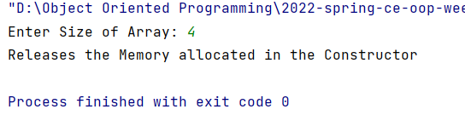

b) Extend task A, with the following information:

Public Member Functions:
//add function to assign values to the array
void add(int)
{
}
//expand function to increase size of the array
void expand(int)
{
}

Do the following operations in main function:

1. Create an object of class, add, and display 5 elements, expand array to 15, add 10 elements, and display them.

(custArray.h)

#ifndef INC_2022_SPRING_CE_OOP_WEEK9_LABTASK_A_BSCE21017_CUSTARRAY_H
#define INC_2022_SPRING_CE_OOP_WEEK9_LABTASK_A_BSCE21017_CUSTARRAY_H
#include <iostream>
using namespace std;
class custArray {
private:
int arraySize;
int noOfElem;
int *arr;
public:
int getNumber(){
return noOfElem;
}
custArray(int _arraySize) { //parameterized constructor
noOfElem = 0;
arraySize = _arraySize; //initialize the size of array
arr = new int[arraySize](); //initialize the array and sets the elements of array to ZERO
}
~custArray() { //destructor definition
delete[] arr; //releases the dynamic memory
cout << "Releases the Memory allocated in the Constructor \n";
}
void add(int data) {
string rep;
int size;
if (arr) {
if (noOfElem < arraySize) {
arr[noOfElem] = data;
noOfElem++;
}
}
}
void expand(int newSize) {
int *arr1 = new int[newSize];
for (int i = 0; i < arraySize; ++i) {
arr1[i] = arr[i];
}
arraySize = newSize;
delete[] arr;
arr = arr1;
}
void display(){
for (int i = 0; i < noOfElem; ++i) {
cout<<arr[i]<<" ";
}
cout<<endl;
}
};
#endif //INC_2022_SPRING_CE_OOP_WEEK9_LABTASK_A_BSCE21017_CUSTARRAY_H

(MAIN FUNCTION)

int main {
size = 5;
cout<<"Size of Array: 5 \n";
custArray test1(size); //declares instance with the parameterized constructor
for (k = 0; k < size; ++k) {
cout << k + 1 << ". Enter Data you want to enter: ";
cin >> data;
test1.add(data);
// size = test1.getSize();
}
cout<<endl;
cout<<"Output: \n";
test1.display();
cout<<endl;
size = 15;
test1.expand(size);
cout<<"Size Expanded by 15 \n";
// num = test1.getNumber();
for (int i = 0; i < 10; ++i) {
cout << k + 1 << ". Enter Data you want to enter: ";
cin >> data;
test1.add(data);
k++;
}
cout<<endl;
cout<<"Output: \n";
test1.display();
return 0;
}

Output:

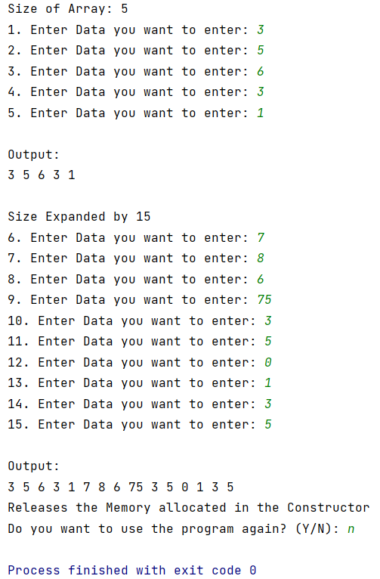

Assessment Rubric for Lab
Method for assessment:

Lab reports and instructor observation during lab sessions. Outcome assessed:
a. Ability to conduct experiments, as well as to analyze and interpret data (P) b. Ability to function on multi-disciplinary teams (A)
c. Ability to use the techniques, skills, and modern engineering tools necessary for engineering practice (P)
Performance metric | Task | CLO | Description | Max marks | Exceeds expectation | Meets expectation | Does not meet expectation | Obtained marks
1. Realization of experiment (a) | 1 | 1 | Functionality | 40 | Executes without errors excellent user prompts, good use of symbols, spacing in output. Through testing has been completed (35-40) | Executes without errors, user prompts are understandable, minimum use of symbols or spacing in output. Some testing has been completed (20-34) | Does not execute due to syntax errors, runtime errors, user prompts are misleading or non-existent. No testing has been completed (0-19)
2. Teamwork (b) | 1 | 3 | Group Performance | 5 | Actively engages and cooperates with other group member(s) in effective manner (4-5) | Cooperates with other group member(s) in a reasonable manner but conduct can be improved (2-3) | Distracts or discourages other group members from conducting the experiment (0-1)
3. Conducting experiment (a, c) | 1 | 1 | On Spot Changes | 10 | Able to make changes (8-10) | Partially able to make changes (5-7) | Unable to make changes (0-4)
 | 1 | 1 | Viva | 10 | Answered all questions (8-10) | Few incorrect answers (5-7) | Unable to answer all questions (0-4)
4. Laboratory safety and disciplinary rules (a) | 1 | 3 | Code commenting | 5 | Comments are added and does help the reader to understand the code (4-5) | Comments are added and does not help the reader to understand the code (2-3) | Comments are not added (0-1)
5. Data collection (c) | 1 | 3 | Code Structure | 5 | Excellent use of white space, creatively organized work, excellent use of variables and constants, correct identifiers for constants, No line-wrap (4-5) | Includes name, and assignment, white space makes the program fairly easy to read. Title, organized work, good use of variables (2-3) | Poor use of white space (indentation, blank lines) making code hard to read, disorganized and messy (0-1)
6. Data analysis (a, c) | 1 | 4 | Algorithm | 20 | Solution is efficient, easy to understand, and maintain (15-20) | A logical solution that is easy to follow but it is not the most efficient (6-14) | A difficult and inefficient solution (0-5)
7. Computer use (c) | 1 | 2 | Documentation & GitHub Submissions | 5 | Timely (4-5) | Late (2-3) | Not done (0-1)
 | Max Marks (total): |  |  | 100 | Obtained Marks (total):

Lab Engineer Signature: ________________________

